**STORED PROCEDURE BASICS**

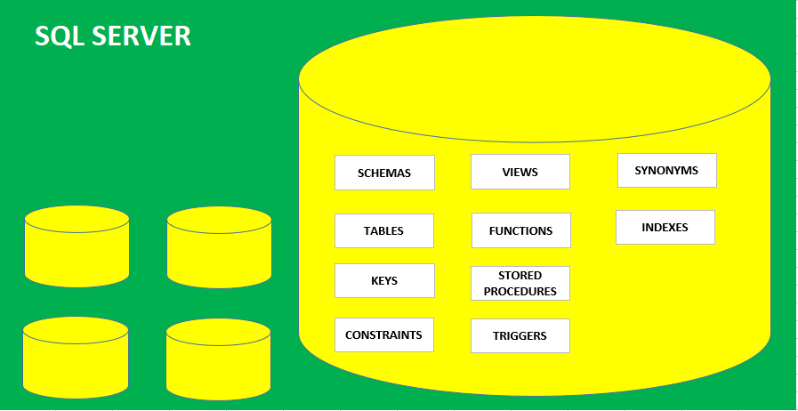

**PROCEDURE**: DATABASE OBJECT USED TO STORE **SELECT, DML, DDL** QUERIES.

FOR PROGRAMMING AND BUSINESS LOGIC IMPLEMENTATION.

EX 1: HOW TO REPORT LIST OF EMPLOYEES FOR A GIVEN COUNTRY

EX 2: HOW TO INSERT DATA INTO EMPLOYEE TABLE

**PARAMETERS**: THESE ARE UNKNOWN INPUT VALUES. WE CAPTURE THESE VALUES FROM FORMS, APPS

DURING PROCEDURE CREATION, WE NEED TO **DEFINE** THESE PARAMETERS USING **@**

DURING PROCEDURE EXECUTION, WE NEED TO **SUPPLY** ABOVE PARAMETER VALUES.

**SYNTAX** CREATE PROCEDURE <PROCEDURE NAME> (@PARAMETER-NAME DATATYPE)

AS

**BEGIN -- TO START THE PROCEDURE DEFINITION**

STATEMENT 1

STATEMENT 2

STATEMENT 3

….

….

**END -- TO END THE PROCEDURE DEFINITION**

**TO EXECUTE A PROCEDURE:**

EXECUTE <PROCEDURE-NAME> OR

EXEC <PROCEDURE-NAME>